Autoloading

I-🔄 What Is Autoloading in PHP?
# Source: AI Source: Provided by: [Data Path: Persons Table -> ID Column: 1, Name_En Column: Motasem Essam] -> From: [Chatgpt (GPT‑5 Mini)] on [1/26/2026]
Autoloading in PHP is a feature that automatically loads class files when they are needed, instead of manually including them with require or include.

II-✅ Simple Definition:
# Source: AI Source: Provided by: [Data Path: Persons Table -> ID Column: 1, Name_En Column: Motasem Essam] -> From: [Chatgpt (GPT‑5 Mini)] on [1/26/2026]
Autoloading lets PHP find and load class files automatically when you use a class — no need to require every file by hand.

III-📦 Example Before Autoloading:
# Source: AI Source: Provided by: [Data Path: Persons Table -> ID Column: 1, Name_En Column: Motasem Essam] -> From: [Chatgpt (GPT‑5 Mini)] on [1/26/2026]
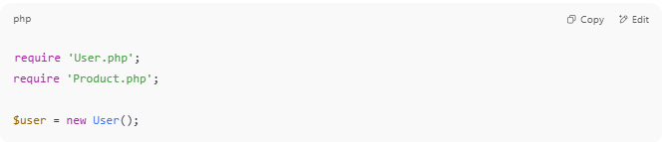
require 'User.php';
require 'Product.php';

$user = new User();

IV-✅ With Autoloading:
# Source: AI Source: Provided by: [Data Path: Persons Table -> ID Column: 1, Name_En Column: Motasem Essam] -> From: [Chatgpt (GPT‑5 Mini)] on [1/26/2026]
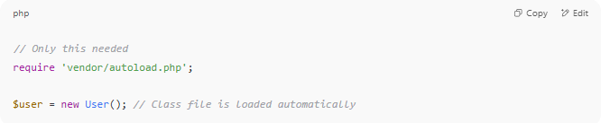
// Only this needed
require 'vendor/autoload.php';

$user = new User(); // Class file is loaded automatically

V-🧠 Why Use Autoloading?
# Source: AI Source: Provided by: [Data Path: Persons Table -> ID Column: 1, Name_En Column: Motasem Essam] -> From: [Chatgpt (GPT‑5 Mini)] on [1/26/2026]
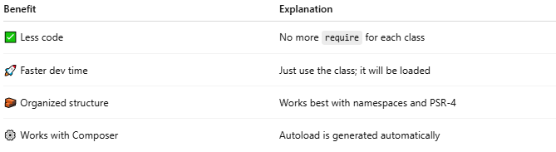
Benefit | Explanation
✅ Less code | No more require for each class
🚀 Faster dev time | Just use the class; it will be loaded
🧱 Organized structure | Works best with namespaces and PSR-4
⚙️ Works with Composer | Autoload is generated automatically

VI-⚙️ Composer Autoloading (PSR-4)
# Source: AI Source: Provided by: [Data Path: Persons Table -> ID Column: 1, Name_En Column: Motasem Essam] -> From: [Chatgpt (GPT‑5 Mini)] on [1/26/2026]
When using Composer, autoloading is handled via the vendor/autoload.php file.
Example composer.json:
# Source: AI Source: Provided by: [Data Path: Persons Table -> ID Column: 1, Name_En Column: Motasem Essam] -> From: [Chatgpt (GPT‑5 Mini)] on [1/26/2026]
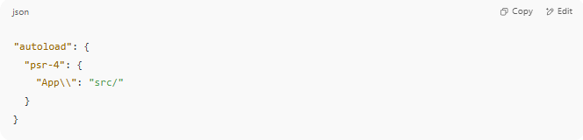
"autoload": {
"psr-4": {
"App\\": "src/"
}
}

Then run:
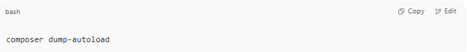
composer dump-autoload

Now PHP will load any class like App\Controller\UserController from:
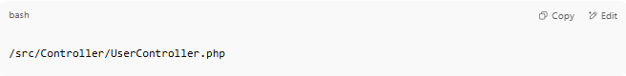
/src/Controller/UserController.php

VII-🔍 How It Works Internally:
# Source: AI Source: Provided by: [Data Path: Persons Table -> ID Column: 1, Name_En Column: Motasem Essam] -> From: [Chatgpt (GPT‑5 Mini)] on [1/26/2026]
PHP uses:
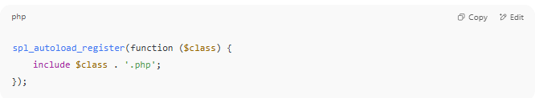
spl_autoload_register(function ($class) {
include $class . '.php';
});

But Composer automates this for you.

VIII-what is composer dump-autoload do

🔁 composer dump-autoload — What Does It Do?
# Source: AI Source: Provided by: [Data Path: Persons Table -> ID Column: 1, Name_En Column: Motasem Essam] -> From: [Chatgpt (GPT‑5 Mini)] on [1/26/2026]
The command:
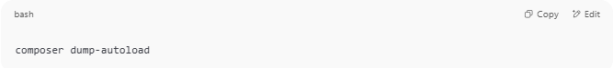
composer dump-autoload

Regenerates Composer's autoloader files so that PHP can automatically load your classes without using require manually.

📂 Why Is This Important?
# Source: AI Source: Provided by: [Data Path: Persons Table -> ID Column: 1, Name_En Column: Motasem Essam] -> From: [Chatgpt (GPT‑5 Mini)] on [1/26/2026]
When you define autoloading in composer.json:
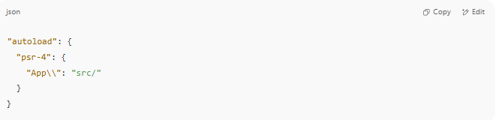
"autoload": {
"psr-4": {
"App\\": "src/"
}
}

Composer uses this rule to map PHP namespaces to file paths.
But for it to work, Composer must generate special files inside the vendor/ directory.

🔧 What composer dump-autoload Does
# Source: AI Source: Provided by: [Data Path: Persons Table -> ID Column: 1, Name_En Column: Motasem Essam] -> From: [Chatgpt (GPT‑5 Mini)] on [1/26/2026]
- Scans the paths you defined in composer.json
- Creates or updates:
  - vendor/autoload.php (main autoload file)
  - vendor/composer/autoload_psr4.php (PSR-4 mappings)
  - vendor/composer/autoload_classmap.php (if needed)
- Enables you to use classes without writing require or include

📌 When Should You Run It?
# Source: AI Source: Provided by: [Data Path: Persons Table -> ID Column: 1, Name_En Column: Motasem Essam] -> From: [Chatgpt (GPT‑5 Mini)] on [1/26/2026]
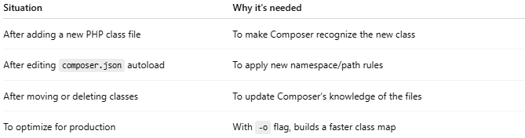

Situation | Why it's needed
After adding a new PHP class file | To make Composer recognize the new class
After editing composer.json autoload | To apply new namespace/path rules
After moving or deleting classes | To update Composer’s knowledge of the files
To optimize for production | With -o flag, builds a faster class map

⚡ Example Command for Production
# Source: AI Source: Provided by: [Data Path: Persons Table -> ID Column: 1, Name_En Column: Motasem Essam] -> From: [Chatgpt (GPT‑5 Mini)] on [1/26/2026]
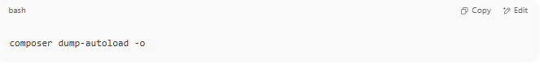
composer dump-autoload -o

- -o = optimize
- Generates a fully optimized class map for faster autoloading (used in live environments)

🧠 Summary
# Source: AI Source: Provided by: [Data Path: Persons Table -> ID Column: 1, Name_En Column: Motasem Essam] -> From: [Chatgpt (GPT‑5 Mini)] on [1/26/2026]
Action | Result
Run composer dump-autoload | Composer rebuilds vendor/autoload.php and mappings
Use autoload in code | require 'vendor/autoload.php'; to enable autoloading

IX-what is autoloader files
# Source: AI Source: Provided by: [Data Path: Persons Table -> ID Column: 1, Name_En Column: Motasem Essam] -> From: [Chatgpt (GPT‑5 Mini)] on [1/26/2026]
Autoloader files are files (generated by Composer) that allow PHP to automatically load your classes without manually writing require or include statements for each file.
They tell PHP:
“If you use this class, I know where to find it.”

⚙️ Main Autoloader File
# Source: AI Source: Provided by: [Data Path: Persons Table -> ID Column: 1, Name_En Column: Motasem Essam] -> From: [Chatgpt (GPT‑5 Mini)] on [1/26/2026]
When you run:
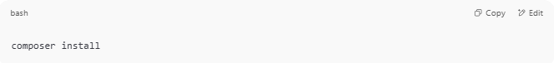
composer install

Or
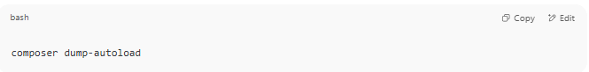
composer dump-autoload

Composer creates the main autoloader file:
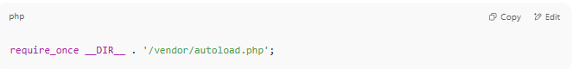
/vendor/autoload.php

You include it once in your project:
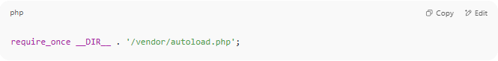
require_once __DIR__ . '/vendor/autoload.php';

And then you can use any class defined in your project or in installed libraries — no manual require.

📁 Composer Autoloader System
# Source: AI Source: Provided by: [Data Path: Persons Table -> ID Column: 1, Name_En Column: Motasem Essam] -> From: [Chatgpt (GPT‑5 Mini)] on [1/26/2026]
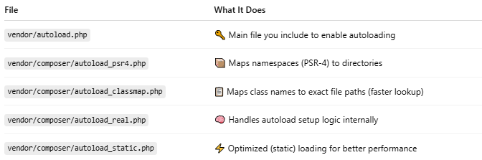
File | What It Does
vendor/autoload.php | 🔑 Main file you include to enable autoloading
vendor/composer/autoload_psr4.php | 📦 Maps namespaces (PSR-4) to directories
vendor/composer/autoload_classmap.php | 📋 Maps class names to exact file paths (faster lookup)
vendor/composer/autoload_real.php | 🧠 Handles autoload setup logic internally
vendor/composer/autoload_static.php | ⚡ Optimized (static) loading for better performance

🧠 Why Use an Autoloader?
# Source: AI Source: Provided by: [Data Path: Persons Table -> ID Column: 1, Name_En Column: Motasem Essam] -> From: [Chatgpt (GPT‑5 Mini)] on [1/26/2026]
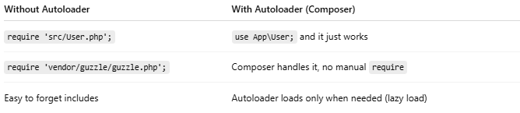

Without Autoloader | With Autoloader (Composer)
require 'src/User.php'; | use App\User; and it just works
require 'vendor/guzzle/guzzle.php'; | Composer handles it, no manual require
Easy to forget includes | Autoloader loads only when needed (lazy load)

✅ Benefits
# Source: AI Source: Provided by: [Data Path: Persons Table -> ID Column: 1, Name_En Column: Motasem Essam] -> From: [Chatgpt (GPT‑5 Mini)] on [1/26/2026]
- 💡 Cleaner code (no manual includes)
- ⚡ Loads only what you use (on demand)
- 📚 Integrates with 3rd-party packages
- 🚀 Faster setup for modern PHP apps

📌 Summary
# Source: AI Source: Provided by: [Data Path: Persons Table -> ID Column: 1, Name_En Column: Motasem Essam] -> From: [Chatgpt (GPT‑5 Mini)] on [1/26/2026]
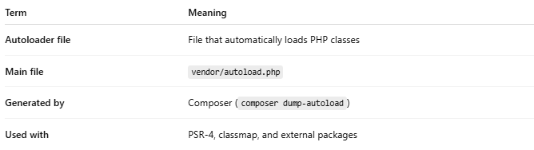

Term | Meaning
Autoloader file | File that automatically loads PHP classes
Main file | vendor/autoload.php
Generated by | Composer (composer dump-autoload)
Used with | PSR-4, classmap, and external packages

X-📘 What Is PSR-4?
# Source: AI Source: Provided by: [Data Path: Persons Table -> ID Column: 1, Name_En Column: Motasem Essam] -> From: [Chatgpt (GPT‑5 Mini)] on [1/26/2026]
PSR-4 stands for PHP Standard Recommendation #4 — a modern standard for autoloading PHP classes using namespaces and directory structure.
It was created by the PHP-FIG (PHP Framework Interop Group).

✅ Simple Definition:
# Source: AI Source: Provided by: [Data Path: Persons Table -> ID Column: 1, Name_En Column: Motasem Essam] -> From: [Chatgpt (GPT‑5 Mini)] on [1/26/2026]
PSR-4 defines how to map a PHP class name (with namespaces) to a file path on disk — so autoloaders like Composer can find and load it automatically.

📁 Example

Class:
# Source: AI Source: Provided by: [Data Path: Persons Table -> ID Column: 1, Name_En Column: Motasem Essam] -> From: [Chatgpt (GPT‑5 Mini)] on [1/26/2026]
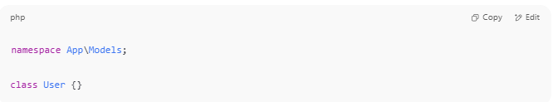
namespace App\Models;

class User {}

File Path (PSR-4):
# Source: AI Source: Provided by: [Data Path: Persons Table -> ID Column: 1, Name_En Column: Motasem Essam] -> From: [Chatgpt (GPT‑5 Mini)] on [1/26/2026]
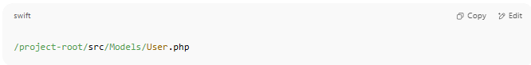
/project-root/src/Models/User.php

Composer.json:
# Source: AI Source: Provided by: [Data Path: Persons Table -> ID Column: 1, Name_En Column: Motasem Essam] -> From: [Chatgpt (GPT‑5 Mini)] on [1/26/2026]
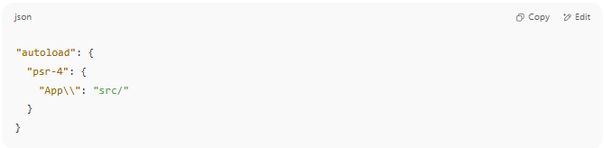
"autoload": {
"psr-4": {
"App\\": "src/"
}
}

After running:
# Source: AI Source: Provided by: [Data Path: Persons Table -> ID Column: 1, Name_En Column: Motasem Essam] -> From: [Chatgpt (GPT‑5 Mini)] on [1/26/2026]
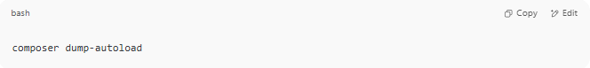
composer dump-autoload

You can use:
# Source: AI Source: Provided by: [Data Path: Persons Table -> ID Column: 1, Name_En Column: Motasem Essam] -> From: [Chatgpt (GPT‑5 Mini)] on [1/26/2026]
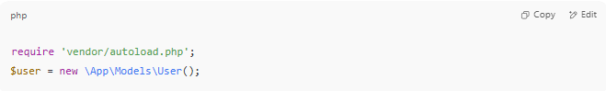
require 'vendor/autoload.php';
$user = new \App\Models\User();

✅ No need to require the file manually.

XI-WHAT IS PSR-4 mappings

🧭 What Is PSR-4 Mapping?
# Source: AI Source: Provided by: [Data Path: Persons Table -> ID Column: 1, Name_En Column: Motasem Essam] -> From: [Chatgpt (GPT‑5 Mini)] on [1/26/2026]
PSR-4 mapping is a rule that tells Composer how to find your PHP classes automatically based on their namespace.
It connects a namespace to a folder path, so Composer can autoload your classes without needing require or include.

📌 PSR-4 = “PHP Standard Recommendation #4”
# Source: AI Source: Provided by: [Data Path: Persons Table -> ID Column: 1, Name_En Column: Motasem Essam] -> From: [Chatgpt (GPT‑5 Mini)] on [1/26/2026]
It defines:
"How to map namespaces to file system directories."

✅ Basic Example of a PSR-4 Mapping
# Source: AI Source: Provided by: [Data Path: Persons Table -> ID Column: 1, Name_En Column: Motasem Essam] -> From: [Chatgpt (GPT‑5 Mini)] on [1/26/2026]
In your composer.json:
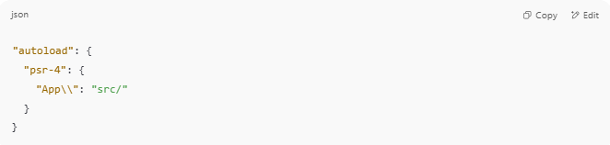
"autoload": {
"psr-4": {
"App\\": "src/"
}
}

🔄 What this means:
# Source: AI Source: Provided by: [Data Path: Persons Table -> ID Column: 1, Name_En Column: Motasem Essam] -> From: [Chatgpt (GPT‑5 Mini)] on [1/26/2026]
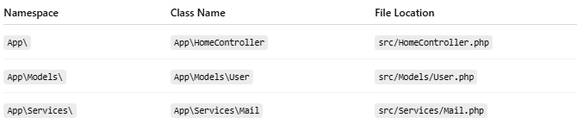

Namespace | Class Name | File Location
App\ | App\HomeController | src/HomeController.php
App\Models\ | App\Models\User | src/Models/User.php
App\Services\ | App\Services\Mail | src/Services/Mail.php
So if you write:
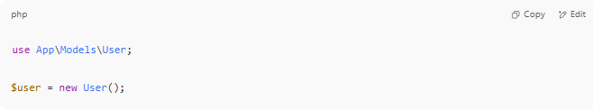
use App\Models\User;

$user = new User();

Composer autoloads the file src/Models/User.php automatically — thanks to the PSR-4 mapping.

🔍 Key Parts of a Mapping
# Source: AI Source: Provided by: [Data Path: Persons Table -> ID Column: 1, Name_En Column: Motasem Essam] -> From: [Chatgpt (GPT‑5 Mini)] on [1/26/2026]
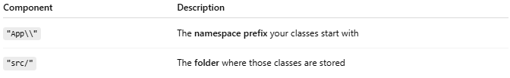

Component | Description
"App\\" | The namespace prefix your classes start with
"src/" | The folder where those classes are stored

🛠 Multiple PSR-4 Mappings
# Source: AI Source: Provided by: [Data Path: Persons Table -> ID Column: 1, Name_En Column: Motasem Essam] -> From: [Chatgpt (GPT‑5 Mini)] on [1/26/2026]
You can define multiple mappings:
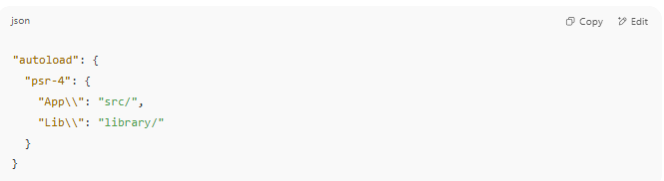
"autoload": {
"psr-4": {
"App\\": "src/",
"Lib\\": "library/"
}
}

This means:
- Classes like App\Controller\Home live in src/Controller/Home.php
- Classes like Lib\Tools\Logger live in library/Tools/Logger.php

🧪 After Adding PSR-4 Mappings
# Source: AI Source: Provided by: [Data Path: Persons Table -> ID Column: 1, Name_En Column: Motasem Essam] -> From: [Chatgpt (GPT‑5 Mini)] on [1/26/2026]
Whenever you define or change PSR-4 mappings:
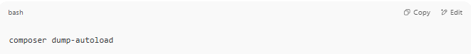
composer dump-autoload

👉 This rebuilds the autoloader files.

✅ Summary
# Source: AI Source: Provided by: [Data Path: Persons Table -> ID Column: 1, Name_En Column: Motasem Essam] -> From: [Chatgpt (GPT‑5 Mini)] on [1/26/2026]
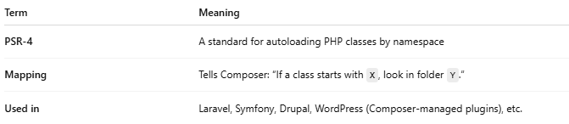

Term | Meaning
PSR-4 | A standard for autoloading PHP classes by namespace
Mapping | Tells Composer: “If a class starts with X, look in folder Y.”
Used in | Laravel, Symfony, Drupal, WordPress (Composer-managed plugins), etc.

XII-🔢 What Was Before PSR-4?
# Source: AI Source: Provided by: [Data Path: Persons Table -> ID Column: 1, Name_En Column: Motasem Essam] -> From: [Chatgpt (GPT‑5 Mini)] on [1/26/2026]
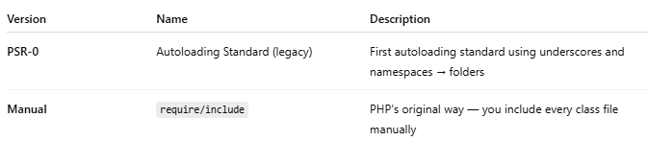
Version | Name | Description
PSR-0 | Autoloading Standard (legacy) | First autoloading standard using underscores and namespaces → folders
Manual | require/include | PHP's original way — you include every class file manually

🆚 PSR-4 vs PSR-0
# Source: AI Source: Provided by: [Data Path: Persons Table -> ID Column: 1, Name_En Column: Motasem Essam] -> From: [Chatgpt (GPT‑5 Mini)] on [1/26/2026]
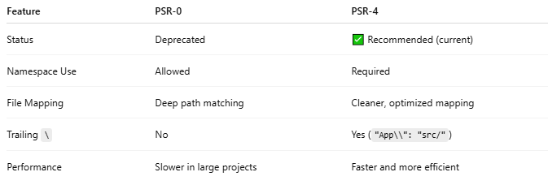

Feature | PSR-0 | PSR-4
Status | Deprecated | ✅ Recommended (current)
Namespace Use | Allowed | Required
File Mapping | Deep path matching | Cleaner, optimized mapping
Trailing \ | No | Yes ("App\\": "src/")
Performance | Slower in large projects | Faster and more efficient

is there other version from PSR-0 and PSR-4
# Source: AI Source: Provided by: [Data Path: Persons Table -> ID Column: 1, Name_En Column: Motasem Essam] -> From: [Chatgpt (GPT‑5 Mini)] on [1/26/2026]
Yes ✅ — in the context of PHP class autoloading, there are only two PSRs that directly relate:

📚 Autoloading Standards
# Source: AI Source: Provided by: [Data Path: Persons Table -> ID Column: 1, Name_En Column: Motasem Essam] -> From: [Chatgpt (GPT‑5 Mini)] on [1/26/2026]
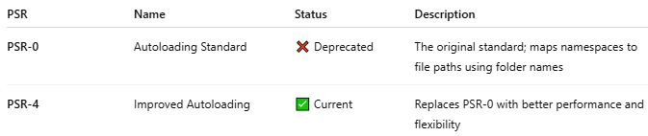

PSR | Name | Status | Description
PSR-0 | Autoloading Standard | ❌ Deprecated | The original standard; maps namespaces to file paths using folder names
PSR-4 | Improved Autoloading | ✅ Current | Replaces PSR-0 with better performance and flexibility

These are the only two PSRs officially related to autoloading.

🔍 What About Other PSRs?
# Source: AI Source: Provided by: [Data Path: Persons Table -> ID Column: 1, Name_En Column: Motasem Essam] -> From: [Chatgpt (GPT‑5 Mini)] on [1/26/2026]
There are many other PSRs, but they cover different topics, such as:
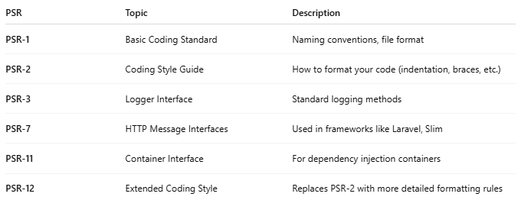

PSR | Topic | Description
PSR-1 | Basic Coding Standard | Naming conventions, file format
PSR-2 | Coding Style Guide | How to format your code (indentation, braces, etc.)
PSR-3 | Logger Interface | Standard logging methods
PSR-7 | HTTP Message Interfaces | Used in frameworks like Laravel, Slim
PSR-11 | Container Interface | For dependency injection containers
PSR-12 | Extended Coding Style | Replaces PSR-2 with more detailed formatting rules

🧾 Summary
# Source: AI Source: Provided by: [Data Path: Persons Table -> ID Column: 1, Name_En Column: Motasem Essam] -> From: [Chatgpt (GPT‑5 Mini)] on [1/26/2026]
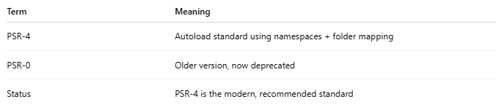

Term | Meaning
PSR-4 | Autoload standard using namespaces + folder mapping
PSR-0 | Older version, now deprecated
Status | PSR-4 is the modern, recommended standard

XIII-🔢 What Was Before PSR-4?
# Source: AI Source: Provided by: [Data Path: Persons Table -> ID Column: 1, Name_En Column: Motasem Essam] -> From: [Chatgpt (GPT‑5 Mini)] on [1/26/2026]

Version | Name | Description
PSR-0 | Autoloading Standard (legacy) | First autoloading standard using underscores and namespaces → folders
Manual | require/include | PHP's original way — you include every class file manually

🆚 PSR-4 vs PSR-0
# Source: AI Source: Provided by: [Data Path: Persons Table -> ID Column: 1, Name_En Column: Motasem Essam] -> From: [Chatgpt (GPT‑5 Mini)] on [1/26/2026]


Feature | PSR-0 | PSR-4
Status | Deprecated | ✅ Recommended (current)
Namespace Use | Allowed | Required
File Mapping | Deep path matching | Cleaner, optimized mapping
Trailing \ | No | Yes ("App\\": "src/")
Performance | Slower in large projects | Faster and more efficient

is there other version from PSR-0 and PSR-4
# Source: AI Source: Provided by: [Data Path: Persons Table -> ID Column: 1, Name_En Column: Motasem Essam] -> From: [Chatgpt (GPT‑5 Mini)] on [1/26/2026]
Yes ✅ — in the context of PHP class autoloading, there are only two PSRs that directly relate:

📚 Autoloading Standards
# Source: AI Source: Provided by: [Data Path: Persons Table -> ID Column: 1, Name_En Column: Motasem Essam] -> From: [Chatgpt (GPT‑5 Mini)] on [1/26/2026]


PSR | Name | Status | Description
PSR-0 | Autoloading Standard | ❌ Deprecated | The original standard; maps namespaces to file paths using folder names
PSR-4 | Improved Autoloading | ✅ Current | Replaces PSR-0 with better performance and flexibility

These are the only two PSRs officially related to autoloading.

🔍 What About Other PSRs?
# Source: AI Source: Provided by: [Data Path: Persons Table -> ID Column: 1, Name_En Column: Motasem Essam] -> From: [Chatgpt (GPT‑5 Mini)] on [1/26/2026]
There are many other PSRs, but they cover different topics, such as:


PSR | Topic | Description
PSR-1 | Basic Coding Standard | Naming conventions, file format
PSR-2 | Coding Style Guide | How to format your code (indentation, braces, etc.)
PSR-3 | Logger Interface | Standard logging methods
PSR-7 | HTTP Message Interfaces | Used in frameworks like Laravel, Slim
PSR-11 | Container Interface | For dependency injection containers
PSR-12 | Extended Coding Style | Replaces PSR-2 with more detailed formatting rules

🧾 Summary
# Source: AI Source: Provided by: [Data Path: Persons Table -> ID Column: 1, Name_En Column: Motasem Essam] -> From: [Chatgpt (GPT‑5 Mini)] on [1/26/2026]


Term | Meaning
PSR-4 | Autoload standard using namespaces + folder mapping
PSR-0 | Older version, now deprecated
Status | PSR-4 is the modern, recommended standard

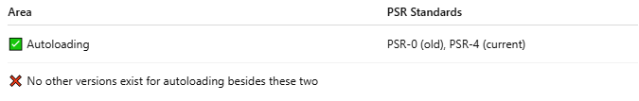

Area | PSR Standards
✅ Autoloading | PSR-0 (old), PSR-4 (current)
❌ No other versions exist for autoloading besides these two

XIV-what is PHP-FIG

🏛️ What Is PHP-FIG?
# Source: AI Source: Provided by: [Data Path: Persons Table -> ID Column: 1, Name_En Column: Motasem Essam] -> From: [Chatgpt (GPT‑5 Mini)] on [1/26/2026]
PHP-FIG stands for PHP Framework Interop Group.

✅ Simple Definition:
# Source: AI Source: Provided by: [Data Path: Persons Table -> ID Column: 1, Name_En Column: Motasem Essam] -> From: [Chatgpt (GPT‑5 Mini)] on [1/26/2026]
PHP-FIG is a group of developers from major PHP frameworks and libraries who create shared standards (called PSRs) to make PHP code more consistent and interoperable.

🧠 Purpose of PHP-FIG:
# Source: AI Source: Provided by: [Data Path: Persons Table -> ID Column: 1, Name_En Column: Motasem Essam] -> From: [Chatgpt (GPT‑5 Mini)] on [1/26/2026]
To solve this problem:
🔁 "Why do Symfony, Laravel, and Zend all structure or log things differently?"
By defining common rules, PHP-FIG helps different frameworks "talk the same language" — so libraries can work together smoothly.

📜 What PHP-FIG Does:
# Source: AI Source: Provided by: [Data Path: Persons Table -> ID Column: 1, Name_En Column: Motasem Essam] -> From: [Chatgpt (GPT‑5 Mini)] on [1/26/2026]
It creates PSRs — PHP Standards Recommendations — that define best practices.
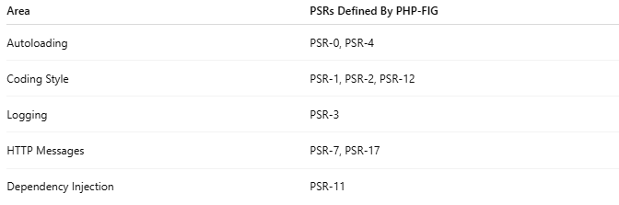
Area | PSRs Defined By PHP-FIG
Autoloading | PSR-0, PSR-4
Coding Style | PSR-1, PSR-2, PSR-12
Logging | PSR-3
HTTP Messages | PSR-7, PSR-17
Dependency Injection | PSR-11

👥 Who's in PHP-FIG?
# Source: AI Source: Provided by: [Data Path: Persons Table -> ID Column: 1, Name_En Column: Motasem Essam] -> From: [Chatgpt (GPT‑5 Mini)] on [1/26/2026]
- Representatives from major frameworks:
  - Symfony
  - Laravel
  - Zend (Laminas)
  - Yii
  - Drupal
  - Composer
  - And more...
They vote and agree on standards together.

🔄 How It Works:
# Source: AI Source: Provided by: [Data Path: Persons Table -> ID Column: 1, Name_En Column: Motasem Essam] -> From: [Chatgpt (GPT‑5 Mini)] on [1/26/2026]
- A proposal is made for a new standard (e.g., PSR-4 for autoloading).
- It goes through review, voting, and approval.
- If accepted, it becomes an official PSR.

🔗 Official Website:
# Source: AI Source: Provided by: [Data Path: Persons Table -> ID Column: 1, Name_En Column: Motasem Essam] -> From: [Chatgpt (GPT‑5 Mini)] on [1/26/2026]
https://www.php-fig.org/

🕓 Timeline of Major PSRs
# Source: AI Source: Provided by: [Data Path: Persons Table -> ID Column: 1, Name_En Column: Motasem Essam] -> From: [Chatgpt (GPT‑5 Mini)] on [1/26/2026]
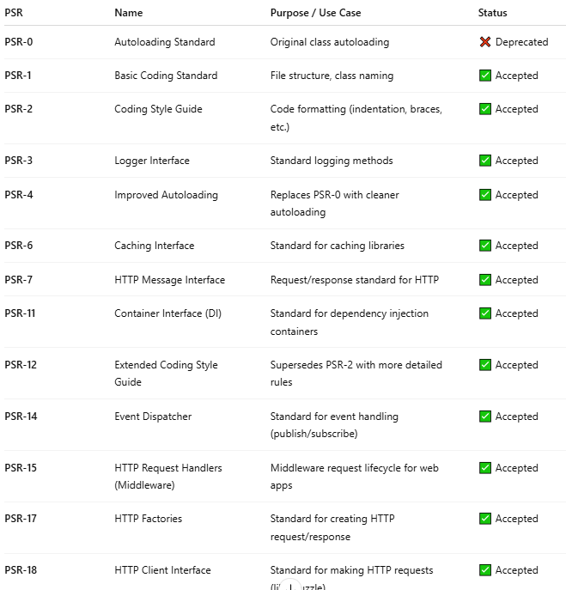

PSR | Name | Purpose / Use Case | Status
PSR-0 | Autoloading Standard | Original class autoloading | ❌ Deprecated
PSR-1 | Basic Coding Standard | File structure, class naming | ✅ Accepted
PSR-2 | Coding Style Guide | Code formatting (indentation, braces, etc.) | ✅ Accepted
PSR-3 | Logger Interface | Standard logging methods | ✅ Accepted
PSR-4 | Improved Autoloading | Replaces PSR-0 with cleaner autoloading | ✅ Accepted
PSR-6 | Caching Interface | Standard for caching libraries | ✅ Accepted
PSR-7 | HTTP Message Interface | Request/response standard for HTTP | ✅ Accepted
PSR-11 | Container Interface (DI) | Standard for dependency injection containers | ✅ Accepted
PSR-12 | Extended Coding Style Guide | Supersedes PSR-2 with more detailed rules | ✅ Accepted
PSR-14 | Event Dispatcher | Standard for event handling (publish/subscribe) | ✅ Accepted
PSR-15 | HTTP Request Handlers (Middleware) | Middleware request lifecycle for web apps | ✅ Accepted
PSR-17 | HTTP Factories | Standard for creating HTTP request/response | ✅ Accepted
PSR-18 | HTTP Client Interface | Standard for making HTTP requests (like Guzzle) | ✅ Accepted

✅ Most Useful PSRs for Developers Today
# Source: AI Source: Provided by: [Data Path: Persons Table -> ID Column: 1, Name_En Column: Motasem Essam] -> From: [Chatgpt (GPT‑5 Mini)] on [1/26/2026]
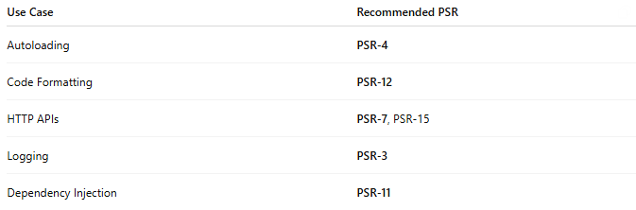

Use Case | Recommended PSR
Autoloading | PSR-4
Code Formatting | PSR-12
HTTP APIs | PSR-7, PSR-15
Logging | PSR-3
Dependency Injection | PSR-11

🧾 Summary
# Source: AI Source: Provided by: [Data Path: Persons Table -> ID Column: 1, Name_En Column: Motasem Essam] -> From: [Chatgpt (GPT‑5 Mini)] on [1/26/2026]
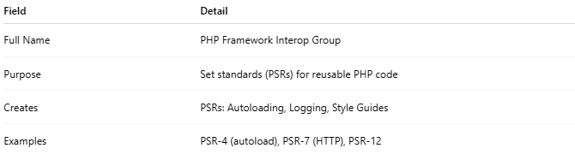

Field | Detail
Full Name | PHP Framework Interop Group
Purpose | Set standards (PSRs) for reusable PHP code
Creates | PSRs: Autoloading, Logging, Style Guides
Examples | PSR-4 (autoload), PSR-7 (HTTP), PSR-12

XV-📍 Where to Include require 'vendor/autoload.php';
# Source: AI Source: Provided by: [Data Path: Persons Table -> ID Column: 1, Name_En Column: Motasem Essam] -> From: [Chatgpt (GPT‑5 Mini)] on [1/26/2026]
You should include:
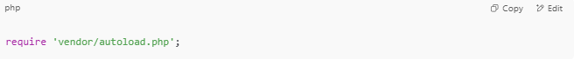
require 'vendor/autoload.php';

at the top of your main entry PHP file — usually the file that starts your application or handles requests.

✅ Common Places to Include It
# Source: AI Source: Provided by: [Data Path: Persons Table -> ID Column: 1, Name_En Column: Motasem Essam] -> From: [Chatgpt (GPT‑5 Mini)] on [1/26/2026]
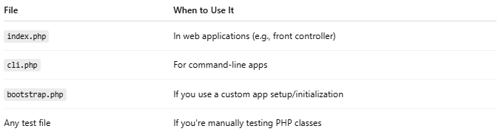

File | When to Use It
index.php | In web applications (e.g., front controller)
cli.php | For command-line apps
bootstrap.php | If you use a custom app setup/initialization
Any test file | If you're manually testing PHP classes

🔁 Example Structure
# Source: AI Source: Provided by: [Data Path: Persons Table -> ID Column: 1, Name_En Column: Motasem Essam] -> From: [Chatgpt (GPT‑5 Mini)] on [1/26/2026]
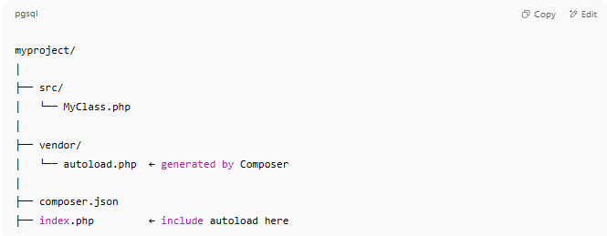
myproject/
│
├── src/
│ └── MyClass.php
│
├── vendor/
│ └── autoload.php ← generated by Composer
│
├── composer.json
├── index.php ← include autoload here

📄 index.php
# Source: AI Source: Provided by: [Data Path: Persons Table -> ID Column: 1, Name_En Column: Motasem Essam] -> From: [Chatgpt (GPT‑5 Mini)] on [1/26/2026]
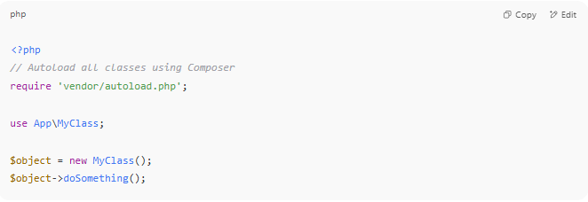
<?php
// Autoload all classes using Composer
require 'vendor/autoload.php';

use App\MyClass;

$object = new MyClass();
$object->doSomething();

Composer’s autoloader now handles all use statements based on your PSR-4 config in composer.json.

❗Important Notes
# Source: AI Source: Provided by: [Data Path: Persons Table -> ID Column: 1, Name_En Column: Motasem Essam] -> From: [Chatgpt (GPT‑5 Mini)] on [1/26/2026]
Make sure you run:
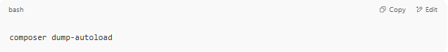
composer dump-autoload
- after creating or updating composer.json or adding classes.

- vendor/autoload.php is generated only after running:
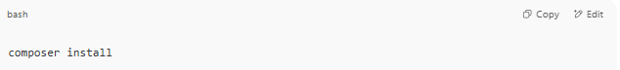
composer install

XVI-🧪 Example: "MyApp" Autoloaded PHP Project
# Source: AI Source: Provided by: [Data Path: Persons Table -> ID Column: 1, Name_En Column: Motasem Essam] -> From: [Chatgpt (GPT‑5 Mini)] on [1/26/2026]
Great! Here's a simple example PHP project using PSR-4 autoloading with Composer. This is how modern PHP projects are structured.

✅ Step 1: Folder Structure
# Source: AI Source: Provided by: [Data Path: Persons Table -> ID Column: 1, Name_En Column: Motasem Essam] -> From: [Chatgpt (GPT‑5 Mini)] on [1/26/2026]
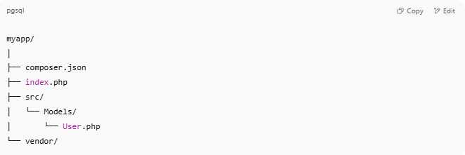
myapp/
│
├── composer.json
├── index.php
├── src/
│ └── Models/
│ └── User.php
└── vendor/

✅ Step 2: Initialize Composer
# Source: AI Source: Provided by: [Data Path: Persons Table -> ID Column: 1, Name_En Column: Motasem Essam] -> From: [Chatgpt (GPT‑5 Mini)] on [1/26/2026]
In your project folder:
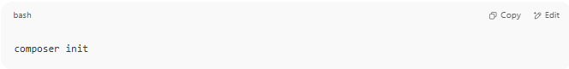
composer init

Answer the prompts, then when asked:
Add PSR-4 autoload mapping?
Enter:
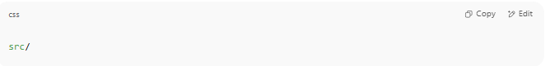
src/

✅ Step 3: composer.json
# Source: AI Source: Provided by: [Data Path: Persons Table -> ID Column: 1, Name_En Column: Motasem Essam] -> From: [Chatgpt (GPT‑5 Mini)] on [1/26/2026]
Make sure it has this:
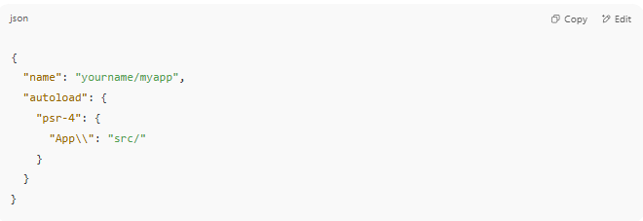
{
"name": "yourname/myapp",
"autoload": {
"psr-4": {
"App\\": "src/"
}
}
}

Then run:
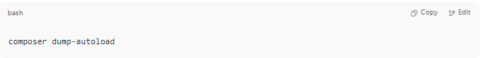
composer dump-autoload

✅ Step 4: Create a Class
# Source: AI Source: Provided by: [Data Path: Persons Table -> ID Column: 1, Name_En Column: Motasem Essam] -> From: [Chatgpt (GPT‑5 Mini)] on [1/26/2026]
📄 src/Models/User.php
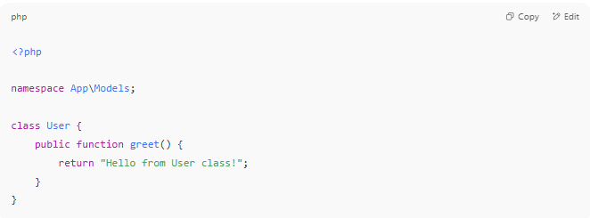
<?php

namespace App\Models;

class User {
public function greet() {
return "Hello from User class!";
}
}

✅ Step 5: Use the Class
# Source: AI Source: Provided by: [Data Path: Persons Table -> ID Column: 1, Name_En Column: Motasem Essam] -> From: [Chatgpt (GPT‑5 Mini)] on [1/26/2026]
📄 index.php
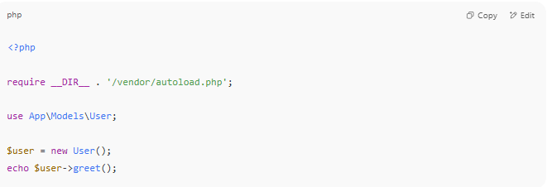
<?php

require __DIR__ . '/vendor/autoload.php';

use App\Models\User;

$user = new User();
echo $user->greet();

✅ Step 6: Run the Project
# Source: AI Source: Provided by: [Data Path: Persons Table -> ID Column: 1, Name_En Column: Motasem Essam] -> From: [Chatgpt (GPT‑5 Mini)] on [1/26/2026]
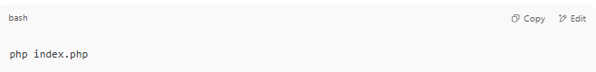
php index.php

✅ Output:
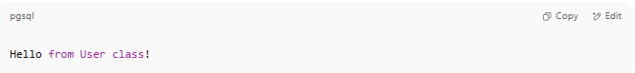
Hello from User class!

🧾 Summary
# Source: AI Source: Provided by: [Data Path: Persons Table -> ID Column: 1, Name_En Column: Motasem Essam] -> From: [Chatgpt (GPT‑5 Mini)] on [1/26/2026]
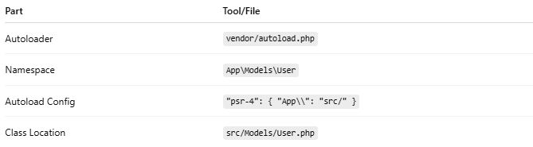

Part | Tool/File
Autoloader | vendor/autoload.php
Namespace | App\Models\User
Autoload Config | "psr-4": { "App\\": "src/" }
Class Location | src/Models/User.php

XVII-🧾 Summary
# Source: AI Source: Provided by: [Data Path: Persons Table -> ID Column: 1, Name_En Column: Motasem Essam] -> From: [Chatgpt (GPT‑5 Mini)] on [1/26/2026]
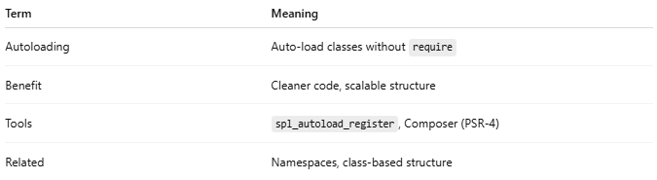

Term | Meaning
Autoloading | Auto-load classes without require
Benefit | Cleaner code, scalable structure
Tools | spl_autoload_register, Composer (PSR-4)
Related | Namespaces, class-based structure

